Accuracy = Number of correct predictions/Number of all Predictions

Note: Accuracy can not be correctly predicted in cases of imbalanced data

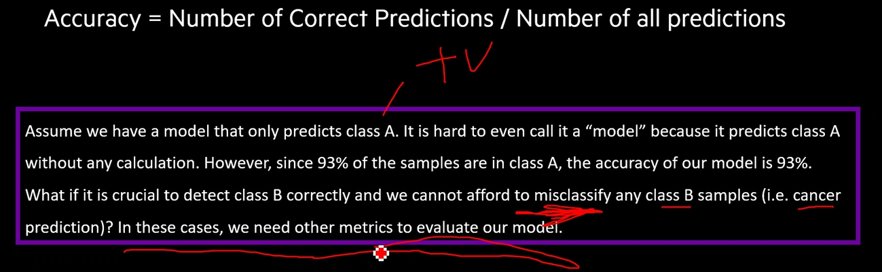

Precision = Tp/(Tp+Fp)

Recall = Tp/(Tp+Fn)

F1 score =2\*(Precision \* Recall)/(Precision+Recall) Note- For calculating accuracy for imbalanced data

Best value for F1 score is 1 and worst value is 0

